APPLESAUCE BREAD

This recipe is taken from The Laurel’s Kitchen Bread Book by Laurel Robertson, except that I substituted coconut oil for the oil. It was a wonderful surprise; truly superb. Very moist and not too sweet. We used our homemade applesauce in the bread. I mill my own wheat, so I used finely ground soft white wheat berries for the “whole wheat pastry flour” and hard red spring wheat berries for the “whole wheat bread flour”.

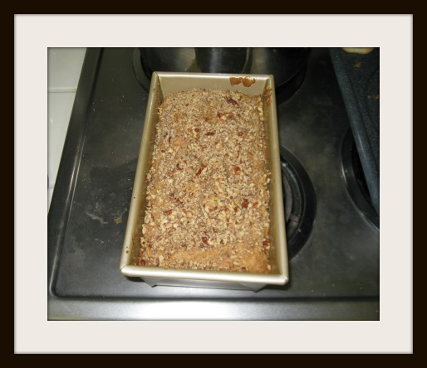
½ C. date sugar or 1/3 C. honey
3 T. coconut oil (or vegetable oil or butter)
1 t. vanilla
½ t. salt
2 C untart applesauce
2 T. lemon juice
1 ½ C whole wheat pastry flour
½ C whole wheat bread flour
2 t. baking powder
½ t. baking soda
1 ½ t cinnamon
½ t. cloves and 1/8 t. nutmeg (optional)
½ C raisins
½ C chopped, toasted walnuts, pecans, or filberts

Preheat oven to 350°F. Grease an 8” by 4” loaf pan.

Use a fork to beat the sweetener and fat, vanilla, and salt. Add the applesauce and lemon juice. Sift the flours and leavenings, and mix the wet and dry ingredients. Fold in the raisins and nuts, reserving about 3 tablespoons of the nuts to sprinkle on top of the loaf before baking.

Spoon into the loaf pan and bake as long as an hour and a half, until done.

If you want a pretty topping for this bread, brush it with melted butter when done, and sprinkle with date sugar, then return to the oven for a couple of minutes.

